Proposal Document

Mina Tahaei 96522204

Mahnaz Haghani Nejad 96521173

Sadra Heydari Moghadam 96441119

The Hooks

**The main hooks of the game include:**

* **The fantasy theme of the game. People love fantasy stories and this game makes them engaged in alluring and mysterious fantasy items such as rustic environments and magical vibes.**
* **Interesting obstacles and powerups related and designed specially according to the physical status and conditions of the main character.**
* **Competition for reaching a higher record, beating your previous scores and earing prizes such as diamonds and coins.**
* **Fantastic and funny audio features according to the theme, occasions, incidents and the whole gameplay.**
* **Simplicity in designing game controls and features, ease of access, easy to approach UX and user-friendly UI. You can easily play this game at any occasion or situation to spend time and have fun.**

Gameplay Mechanics

* The Game Background and environment

The background of this game is a dungeon with brick walls, chains and a large fire at the bottom of the pit/page.

* Controllers

Two blowers located at the bottom left and the bottom right of the screen, which blow out a stream of air, close, then re-open when clicked on them. in the color scheme of chocolate/brown.

They are used to change the direction of the main character and control it.

The Pause and replay Button is in the shape of a bell, hanging at the top left of the page. When the player clicks on it or pulls the bell down, the menu opens; asking them about the options of pause, replay and return to the main menu.

The Main Menu consists of the options Play, High Scores and Exit the game, with design. The High Scores option opens a new menu which holds all of your scores for each time you played and shows the highest one at the top.

The Game Over menu appears when you lose, showing the replay button, the return to the main menu button and your high score and prize.

* Powerups

There are several Powerup objects:

1. The Electric sign(sphere): if the main character touches this item, the blowers will earn a double power capacity of blowing air into the game for controlling the main character. This sphere can appear at any part of the playing back ground.
2. The Ventilation System: This item looks like a ventilation pipe located at the sides of the playing background. If the main character goes in front of it, it will be sucked into the pipe and will fall down again from the top of the page.
3. The little phoenix: This powerup is asleep on branches located at the sides of the playing background. If the main character falls on its head it will wake up, flies and carries the feather and lets it fall down from the top of the page.

* Power downs

There are several Power down objects:

1. The Scissors: This object looks like a pair of scissors connected to a pair of hands holding it and an accordion opener. It opens and closes in the width of the page, if the main character gets stuck between the blades or hits the opener, it will be ripped apart and Game Over.
2. The Boxing Gloves: This object is a pair of boxing gloves attached to an accordion opener, which open and close in the width of the page in opposite direction. If the main character is stuck between the closed gloves, its smashed and Game Over.
3. The Pizza Cutter: This Power down is an electric cutter located at the sides of the page attached to the walls and its working. If the main character touches it, it will be ripped apart and Game Over.
4. The Waterfall: This Power down looks like a pipe, dripping a stream of water into a puddle underneath it. The pipe and the puddle of water are both attached to the walls. If the main character hits the water stream and falls into the puddle it will be Game Over, but if it hits the water stream and escapes it will be heavy and its speed increases and you need to control it fast before it reaches the pit fire. Your score will also be reduced.
5. The Pit Fire: this item is a constant power down. Its always located at the bottom of the page and if the main character falls into it, it will turn into a phoenix and flies away and it will be game over

* Bonus Objects/Items

1. The Silver Bar sphere: when the main character touches it, the record score increases by 1000 points.
2. The Gold Bar sphere: when the main character touches it, the record score increases by 2000 points.

* Point of view

Third Person

Online Features

At this point; there are no online features available for this game and its totally offline; But in the next versions online features such as shopping store and etc. will be added.

Technology

Game Engine: Unity Game Engine Pro 2017

Audio Features: FL studio version 20

Graphic Features : Adobe Photoshop 2018

Animation Features : Adobe After Effect 2018

Minimum system required :

Phone: Android OS from version 4.0, at least 50 Mb of memory,

1 Ghz CPU

PC: Windows 7/8/8.1/10, at least 300 Mb of memory,

1 Ghz CPU x64

Art and Audio Features

Main theme song composed and licensed by Mina Tahaei

Main Game song composed and licensed by Mina Tahaei

Object sounds composed and licensed by Mina Tahaei

Artworks, Objects, Environments and Characters designed and licensed by Mahnaz Haghani Nejad

Story and Characters

* Main Character

The main character of this game is a feather and, in the end, a phoenix.

* Main plot Idea and story

The main plot and story of this game is to avoid obstacles and not allowing the main character to be destroyed, and to prevent the main character from falling in the fire and turning into a phoenix by using the controllers. The more and longer you can control the feather; the higher your record and score.

* Problems faced by the character

The problems faced by the main character are:

* 1. The pit Fire
  2. The power downs (explained with details in the Game Mechanics)
* The villains in the game

There are no living villain characters in this game: the power down objects and the problems are the villains.

* How the player will ultimately overcome all of this

The player will finally overcome all of this by maintaining a long strike at avoiding obstacles, not falling in the fire and setting a highest score and record each time for themselves.

Walkthrough

At first, the game starts by the feather falling down from the top of the page at a constant speed, then the controllers start functioning and the player can use them to control the feather. For the first 10 seconds of the game, the player doesn’t face any obstacles except for the fire which is always available, and the controlling. From second 10 to 25, the scissors power down will be activated, and the speed will increase by a little. From second 25 to 40, the boxing gloves power down will be activated, alongside with electric sign powerup. The speed will also increase. From second 40 to 55, the pizza cutter power down will be activated, the speed will increase and the powerups remain the same. From second 55 to 70, the ventilation powerup will be activated with no new power downs, and the speed increases. From second 70 to 85, the waterfall power down and the little phoenix powerup will be activated with speed increase, and from then it continues according to the player’s skill on handling the speed and obstacles till the Game Over if the player fails.

Production Details

The game is still in the concept development and beginning stages of designing and drawing the objects, plus the beginning of the development coding and audio designing.

Development Budget and Schedule

This project is still a class project and has no budget assigned to it. The schedule for developing and maintaining each part is discussed by the professor in a separate document.

The Team

Mina Tahaei : Team manager, Story Designer, Developer and Audio Engineer / Composer

Mahnaz Haghani Nejad: Graphic Designer, Animation Producer, Story Designer and Developer

Sadra Heydari Moghadam: Developer

Risk Analysis

The risks this project might face, include lagging behind the schedule because this is the first project of the team and the team is novice. However; the team will try and use all of the available times for developing this project so this game doesn’t lag behind.

Concept Art

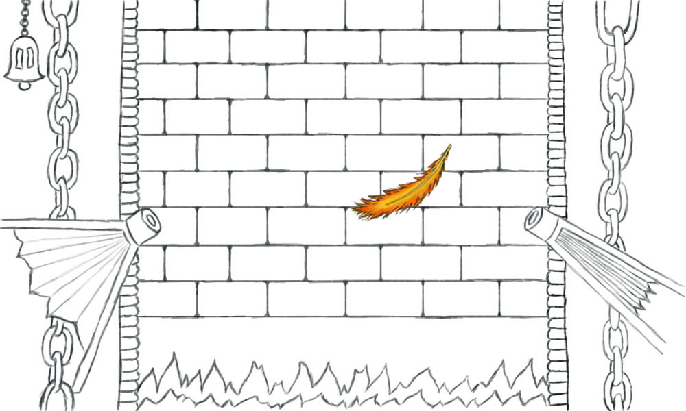

Summary

The major selling points of the game would be:

1. newly designed graphic function and controls not used in similar games
2. newly designed obstacle functions and objects
3. fantasy and magical theme of the game
4. simple design and controls and ease of access and play at any time and occasion
5. suitable audio reactions

Our team is the right team for doing this project because we are passionate and creative and we don’t let go of a problem until we solve it. We have a detailed plan for making this project a perfect game with a good potential and we believe that our idea is fun and entertaining and can attract a major group of customers.